CONTENIDOS  TEMAS Y SUBTEMAS | SECUENCIA DIDACTICA  ACTIVIDADES |  |  | MATERIALES CURRICULARES DE APOYO Y RECURSOS DIDACTICOS
FORMATIVE  LUNES 6 SEP  TOPIC: SUBJECT AND OBJECT PRONOUNS  EXPECTED LEARNING: KNOW THE GRAMMAR TENSES  MARTES 7 SEP  STUDENT BOOK UNIT 2  MIERCOLES 8 SEP  STUDENT BOOK: UNIT 2  JUEVES 9 SEP  READING COMPREHENSION  STUDENT BOOOK UNIT 2  VERNES 10 SEP  WORKBOOK: PAGES 16-17 | INICIO | DESARROLLO | CIERRE | Iibreta, hoja impresa  Book  Book  Book, hoja impresa  book
 | COPY THE TOPIC  START WITH UNIT 2  STUDENT BOOK PAGES 24-25  START WITH READING COMPREHENSION  ANSWER ALONE THE WORKBOK | WATCH A VIDEO AND EXPLAIN  STUDENT BOOK PAGES 22-23  WORKBOOK: PAGES 16  THEN CONTINUE WITH STUDENT BOOK  THEY HAVE TO ANSWER ALONE AND START COMPREHEND THE GRAMMAR RULES | MAKE AND ACTIVITY  ANSWER WORKBOOK 14-15  ANSWER ALONE AND COMPARE ANSWERS  USE PLATFORM  COMPARE ANSWERS
AQUÍ DEBAJO COLOCAR LO QUE SE OCUPA IMPRIMIR

MONDAY, SEPTEMBER 6TH, 2021.
TOPIC: SUBJECT AND OBJECT PRONOUN
E.L: KNOW THE DIFFERENCES BETWEEN BOTH.

We use a pronoun when we don't want to repeat a noun or a noun phrase.
Subject pronouns
The English subject pronouns are: I, you, he, she, it, we they. (Of course, we use 'you' when we're talking to one person and when we're talking to more than one person.)
We use these pronouns when they are the subject of a verb.
- I like London.
- You have eaten the chocolate.
- He plays football.
Object Pronouns
In English, we also have object pronouns. These are: me, you, him, her, it, us, them. (Notice that 'it' and 'you' are the same when they're subject pronouns or object pronouns.)
We use the object pronouns in most situations when the pronoun is not the subject of a verb.
We use them for the object of a verb.
- John knows me.
- Amanda kissed you
We use them after a preposition (including after phrasal verbs).
- It's important to me.
- Can the children come with you?
We use them after 'be'. (In very formal English, the subject pronoun is sometimes used here, but this is very old-fashioned and unusual.)
- Who's there? It's me!
- It's you.
We use them with short answers.
- A: Who's there? B: Me!
- A: Who ate the cake? B: Him!
We use them after 'as' and 'than' for comparison.
- She is as tall as me.
- He is taller than her.
We use them after 'but' and 'except'.
- Everybody went home early but me.
- Everybody went home early except him.
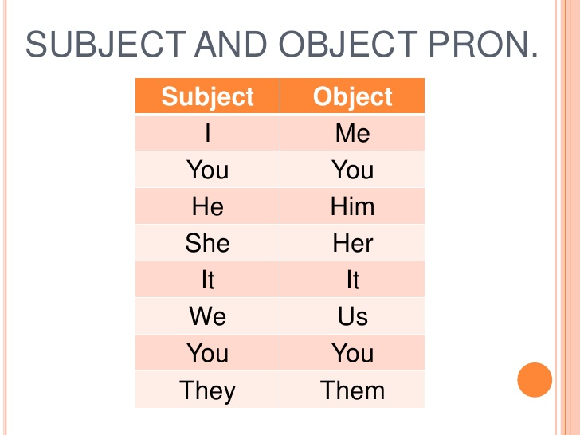

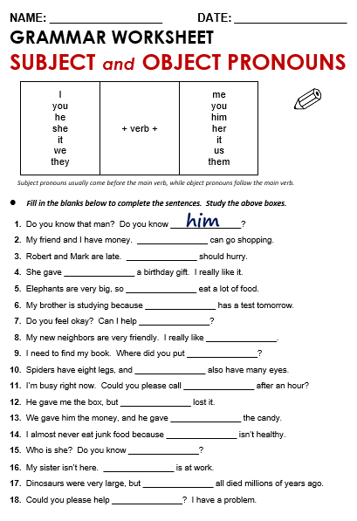

2-WE
3-THEY
4-ME
5-THEY
6-HE
7-YOU
8-THEM
9-IT
10-THEY
11-ME

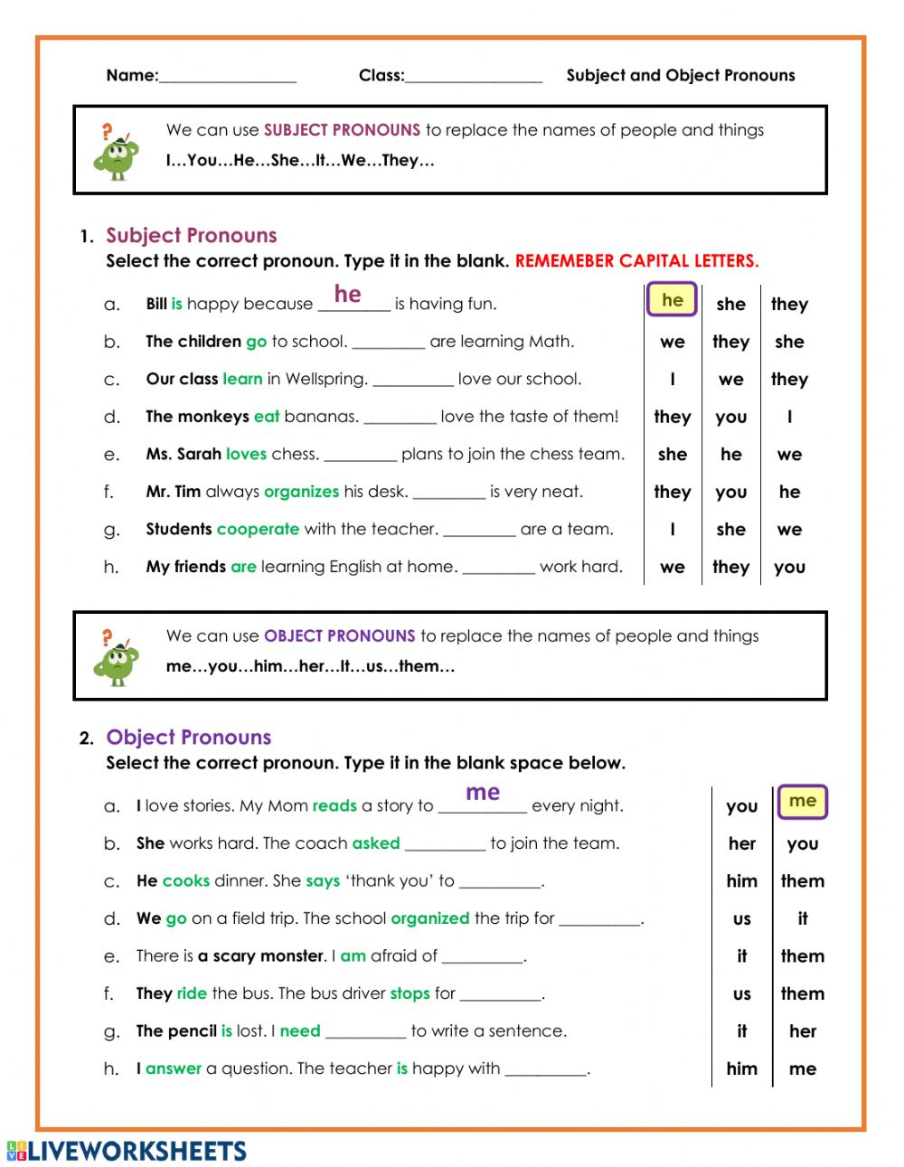
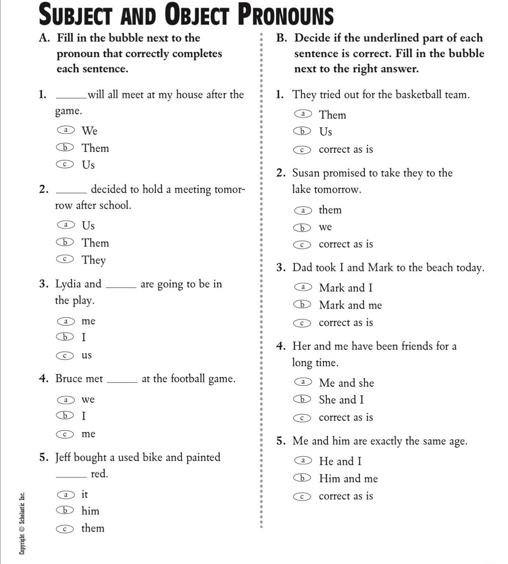

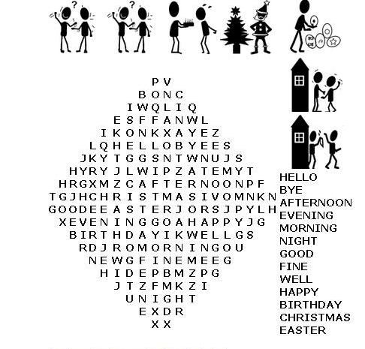
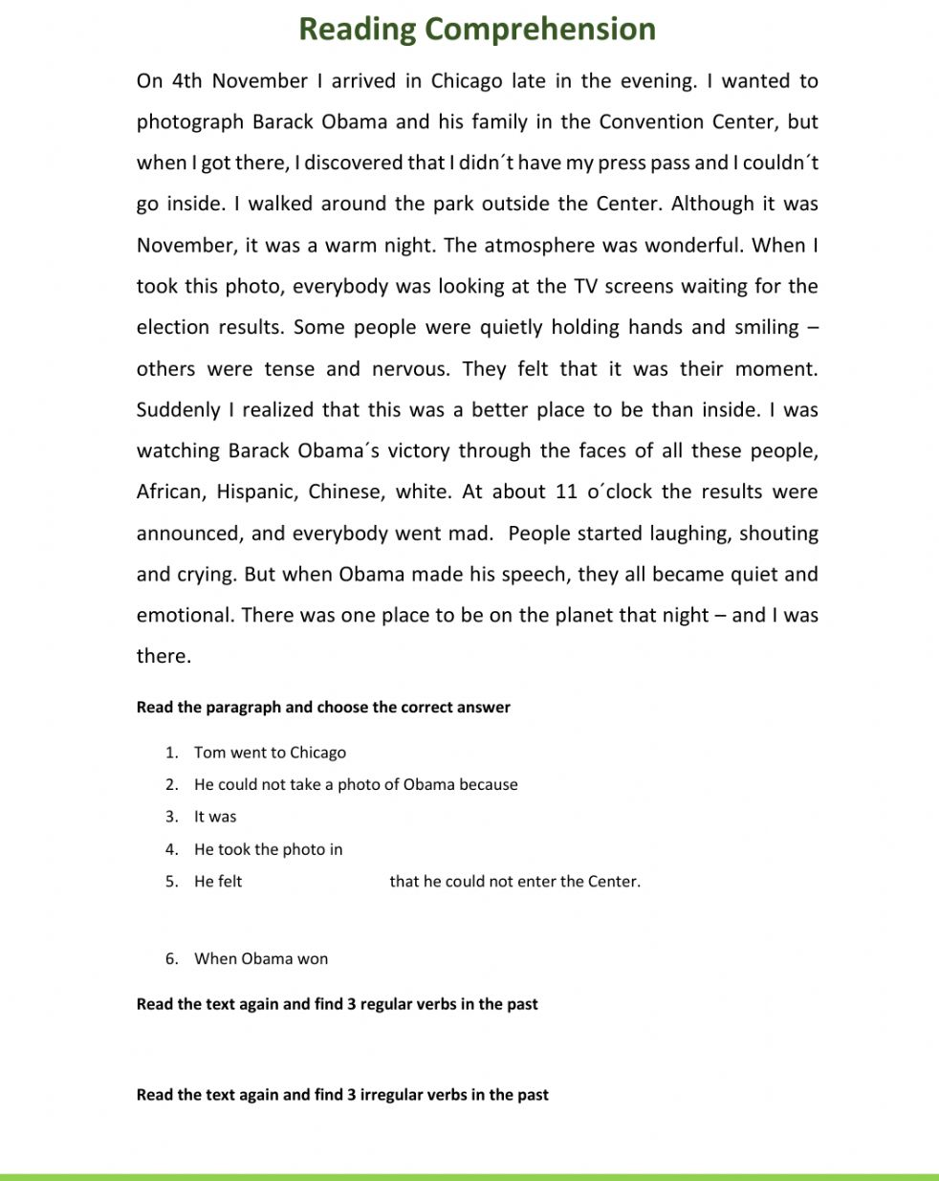

}

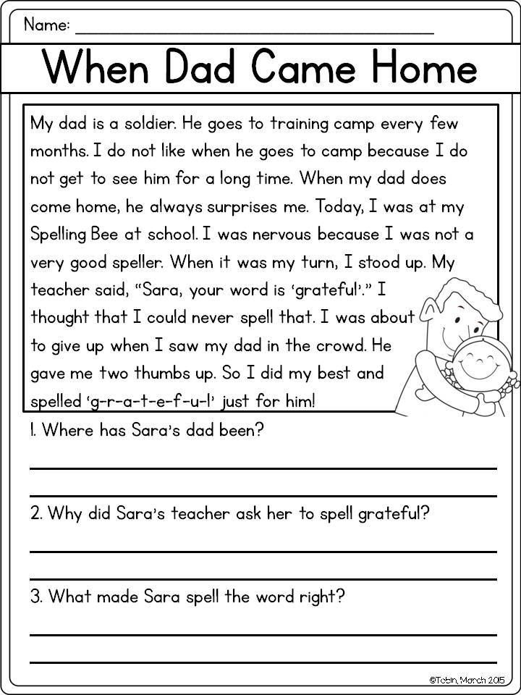

Object Pronouns
In English, we also have object pronouns. These are: me, you, him, her, it, us, them. (Notice that 'it' and 'you' are the same when they're subject pronouns or object pronouns.)
We use the object pronouns in most situations when the pronoun is not the subject of a verb.
We use these pronouns when they are the subject of a verb.
- I like London.
- You have eaten the chocolate.

We use a pronoun when we don't want to repeat a noun or a noun phrase.
The English subject pronouns are: I, you, he, she, it, we they. (Of course, we use 'you' when we're talking to one person and when we're talking to more than one person.)
SUBJECT AND OBJECT PRONOUNS

