CONTENIDOS  TEMAS Y SUBTEMAS | SECUENCIA DIDACTICA  ACTIVIDADES |  |  | MATERIALES CURRICULARES DE APOYO Y RECURSOS DIDACTICOS
BACHILLERATO 3  LUNES 4 OCT  TOPIC: PRESENT CONTINUOUS  MARTES 5 OCT  TOPIC: OBJECT PRONOUNS  MIERCOLES 6 OCT  STUDENT BOOK: UNIT 4  JUEVES 7 OCT  WORKBOOK: UNIT 4 | INICIO | DESARROLLO | CIERRE | LIBRETA, HOJA IMPRESA Y VIDEO  LIBRETA, HOJA IMPRESA Y VIDEO  BOOK, PLATFORM  BOOK, PLATFORM
 | COPY THE TOPIC  COPY THE TOPIC  ANSWER THE BOOK  ANSWER THE BOOK | EXPLAIN , WATCH A VIDEO  EXPLAIN , WATCH A VIDEO  USE THE PLATFORM  USE THE PLATFORM | ANSWER ACTIVITY  ANSWER ACTIVITY  COMPARE ANSWERS  COMPARE ANSWERS

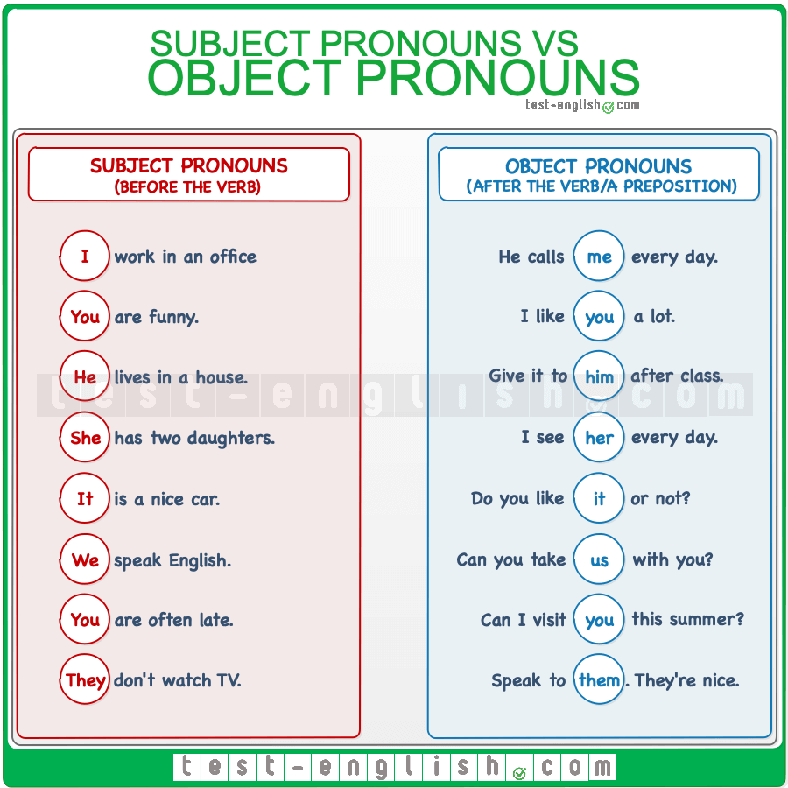

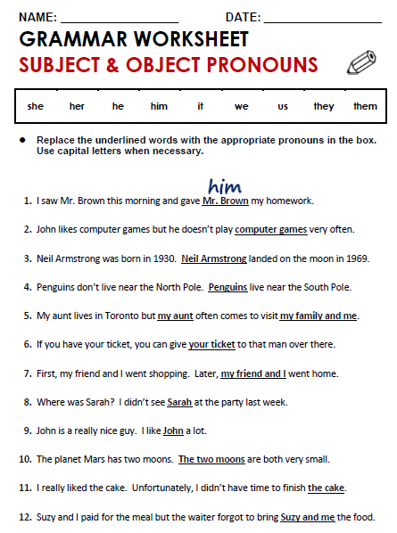

2-them
3-he
4-they
5-he us
6-it
7-we
8-her
9-him
10-they
11-it
12-us

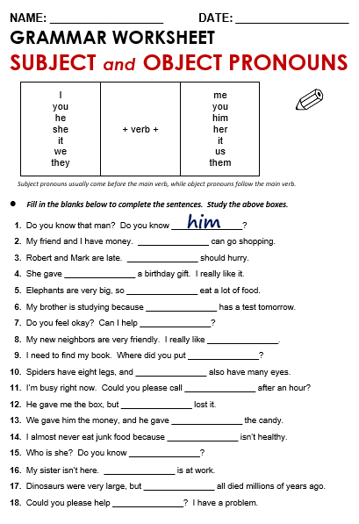

15-her
16-she
17-they
18-me

Ç

TOPIC: PRESENT CONTINUOUS.
Is a verb tense which is used to show that an ongoing action is happening now, either at the moment of speech or now in a larger sense. The present continuous can also be used to show that an action is going to take place in the near future.

PRESENT CONTINUOUS
EXAMPLES:
Statement: You are watching TV.
Question: Are you watching TV?
Negative: You are not watching TV.

The present continuous is formed using:
am/is/are+verb (ing)
- Questions are indicated by inverting the subject and am/is/are.

- Negatives are made with not.

USES OF PRESENT CONTINUOUS:
USE 1 Now
Are you sleeping?
I am sitting.
USE 2 Longer Actions in Progress Now
I am studying to become a doctor.
USE 3 Near Future
I am meeting some friends after work.
USE 4 Repetition and Irritation with "Always"
She is always coming to class late.

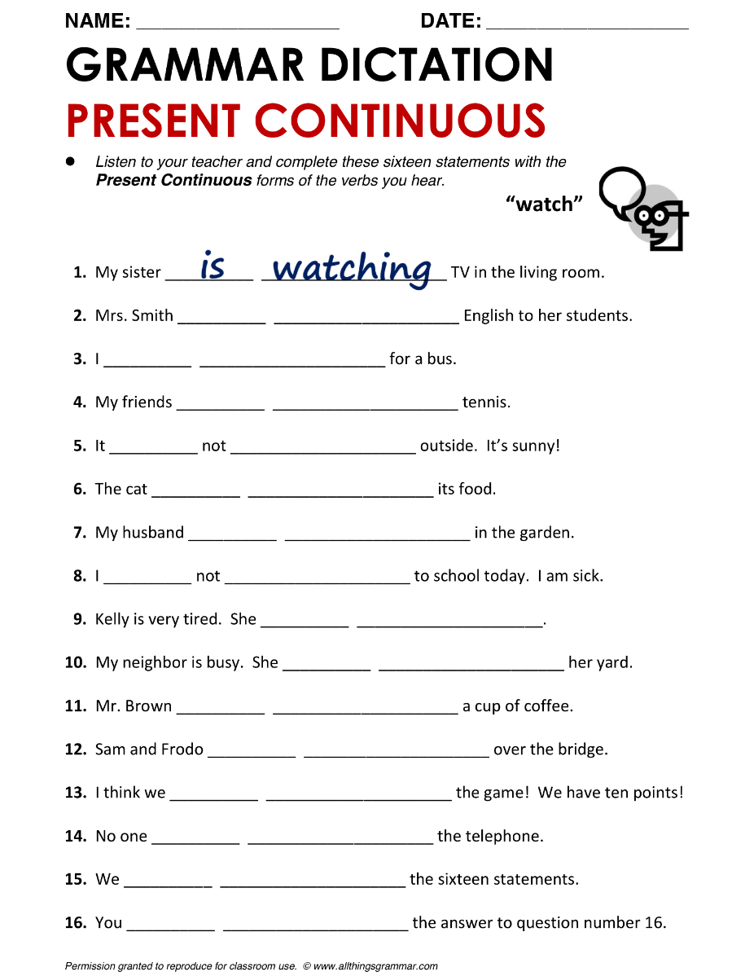

2-is teaching
3-am waiting
4-are playing
5-is rainning
6-is eating
7-is working
8-am going
9-is sleeping
10-is painting
11-is drinking
12-are walking
13-are winning
14-is answering
15-are completing
16-are writing

