CONTENIDOS  TEMAS Y SUBTEMAS | SECUENCIA DIDACTICA  ACTIVIDADES |  |  | MATERIALES CURRICULARES DE APOYO Y RECURSOS DIDACTICOS
FORMATIVE  LUNES 22 NOV  PASTE THE FAJILLA  PASTE THE VOCABULARY  REPEAT VOCABULARY 1-30.  MARTES 23 NOV  TOPIC: COMPARATIVES  ANSWER WORKSHEETS  WATCH A VIDEO  MIERCOLES 24 NOV  SB: PAGE 58-59.  WB:PAGE 40.  JUEVES 25 NOV  SB: PAGE 60-61.  WB: PAGE 41.  VIERNES 26 NOV  TOPIC: SUPERLATIVES  ANSWER WORKSHEETS  WATCH A VIDEO | INICIO | DESARROLLO | CIERRE | HOJA COLOR NARANJA CLARO
 | PASTE THE FAJILLA  COPY THE TOPIC  ANSWER SB PAGE 58-59  ANSWER SB PAGE 60-61  COPY THE TOPIC | PASTE THE VOCABULARY  WATCH THE VIDEO  ANSWER WB PAGE 40  ANSWER WB PAGE 41  WATCH THE VIDEO | REPEAT VOCABULARY 1-30.  ANSWER THE WORKSHEETS  ANSWER WB PAGE 40  ANSWER WB PAGE 41  ANSWER THE WORKSHEETS

THIRD BIMONTH

TERM:
- COMPARATIVES
- SUPERLATIVES
- MODAL VERBS
- REFLEXIVE PRONOUNS

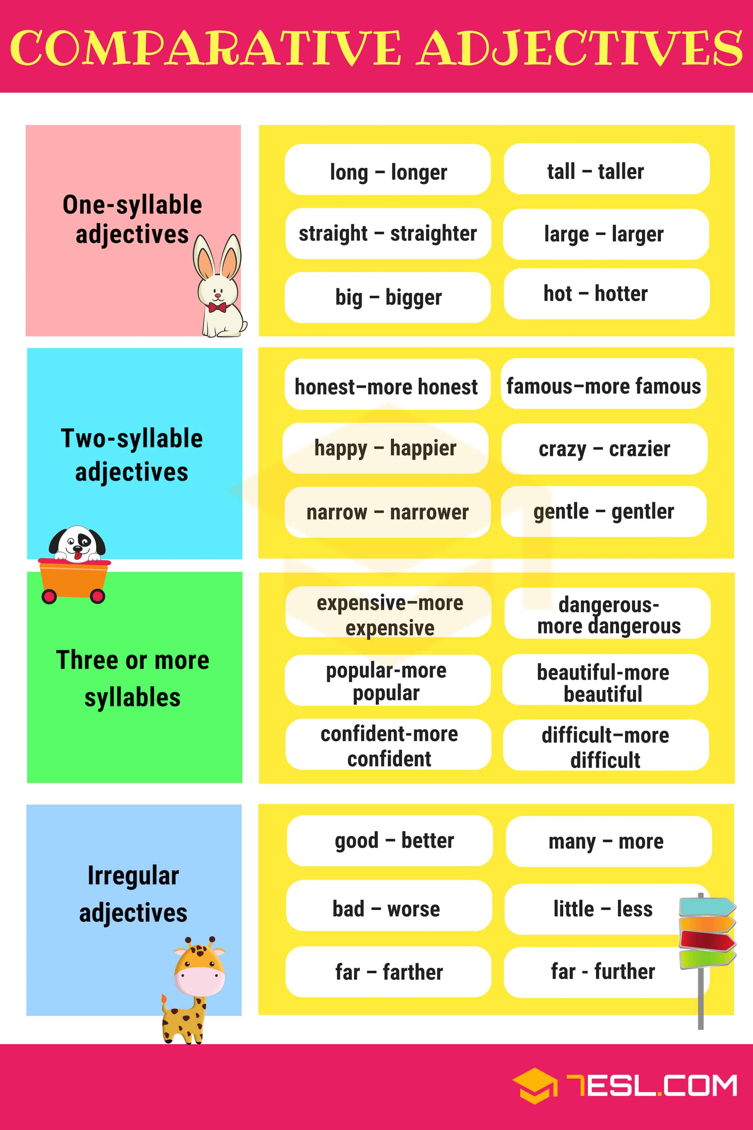
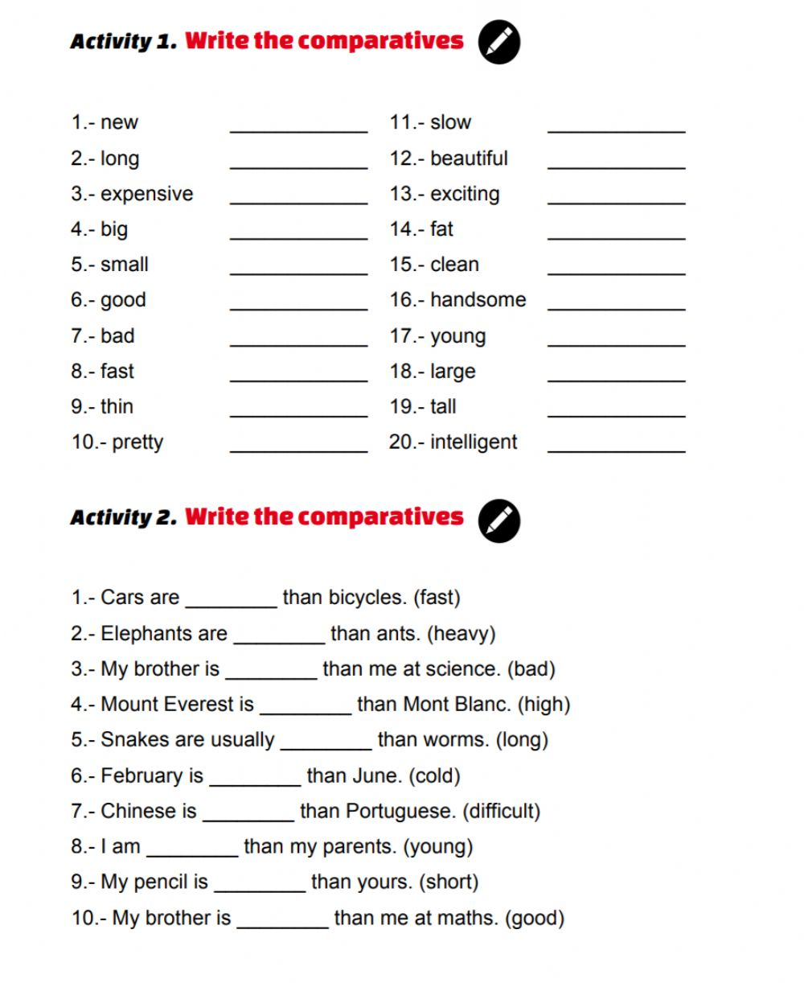

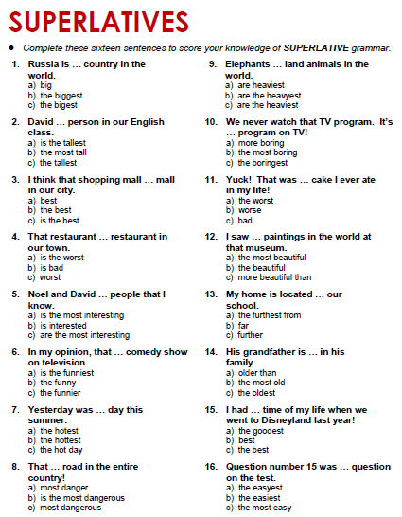
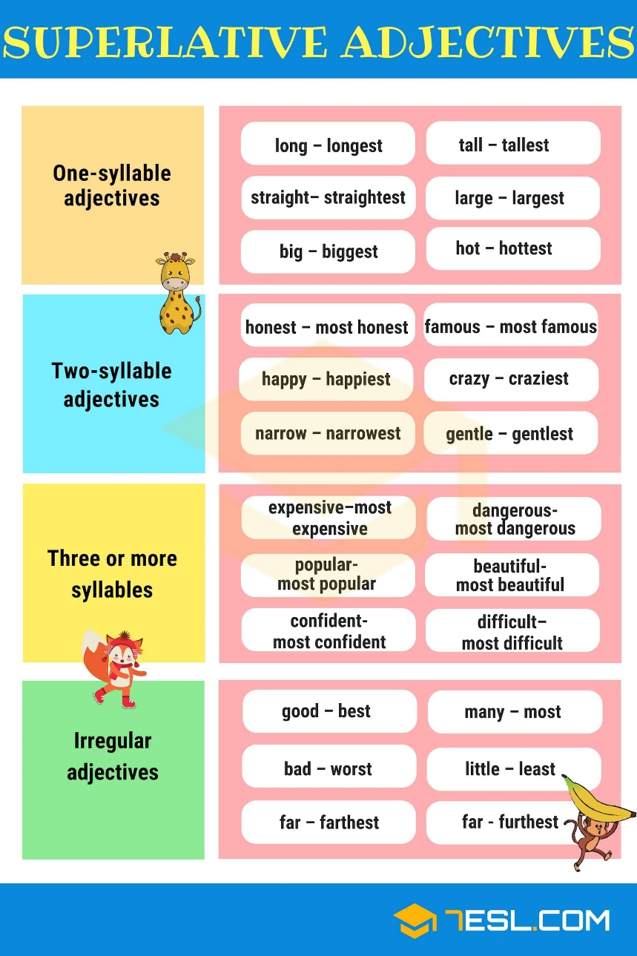
ENGLISH WORD | DEFINITION
Attractive | if something is attractive, people want to see it, go to it, or have it
Dull- | not interesting or exciting
happy | having feelings of pleasure, for example because something good has happened to you or you are very satisfied with your life
industrial | an industrial country or area has a lot of industries
lively | a place or situation that is lively is exciting because a lot of things are happening
modern | made or done using the most recent designs, methods, ideas, etc.
quiet | without much activity or without many people
relaxed | a situation or attitude that is relaxed is informal and not strict
safe | not likely to cause any physical injury or harm
traditional | following ideas and methods that have existed for a long time, rather than doing anything new or different
apartment block | a large building containing many apartments
art gallery | a building where paintings are shown to the public
bike rack | a metal frame that you can attach your bike to
bus stop | a place at the side of a road, marked with a sign, where buses stop for passengers
crossing | a marked place where you can safely cross a road
department store | a large shop that is divided into separate departments, each selling a different type of goods
pavement | a hard level surface or path at the side of a road for people to walk on
rubbish bin | a container for putting waste in
seat | a place where you can sit
skate park | an area for skateboarders to use, which has special slopes or other structures
sports centre | a building where people can go to play many different types of indoor sports
swimming pool | a structure that has been built and filled with water for people to swim in
by the sea/water | near an area of water such as the sea, a lake, etc.
in an area / a region called | in a particular part of a country, town, etc. whose name is …
in the capital | in an important city where the main government of a country, state, etc. is
in the centre of | the middle part or point of something
in the north/south/east/west | in the direction that is at the top of a map of the world, above the Equator / in the direction that is at the bottom of a map of the world, below the Equator / in the direction from which the sun rises, and which is on the right if you are facing north / in the direction towards which the sun goes down, and which is on the left if you are facing north
near the border with | only a short distance from the official line that separates two countries, states, or areas, or the area close to this line
near the capital | only a short distance from an important city where the main government of a country, state, etc. is
near the mountains | only a short distance from an area with several mountains
on the coast | on the land near the sea
at the back | in the part of something that is furthest from the front
at the front | in the part of something that is furthest forward
on the left | on the same side of something as your left side
on the right | on the same side of something as your right side
community | the people who live in the same area, town, etc. or who have the same interests, religion, race, etc.
freeze | if a liquid or something wet freezes or is frozen, it becomes hard and solid because the temperature is very cold
hang out | to spend a lot of time in a particular place or with particular people
lift | if you give someone a lift, you take them somewhere in your car
open | honest and not wanting to hide any facts from other people
pressure | conditions in your life that make you feel worried because you have too much to do or think that you must do well
be the best at something | to be better than anyone else in quality, skill, etc.
concrete | a substance used for building that is made by mixing sand, water, small stones, and cement
cycle path | path for cycles in a park, wood, etc., or beside a road
design | the way that something has been planned and made, including its appearance, how it works, etc.
give up | to stop doing something, especially something that you do regularly
grow up | to develop from being a child to being an adult
library | a room or building containing books that can be looked at or borrowed
made of wood | built of the material that trees are made of
meet up | to meet someone in order to do something together
park | a large open area with grass and trees, especially in a town, where people can walk, play games, etc.
pass the time | to spend time, especially when you are waiting for something or are bored
shape | the form that something has, for example round, square, triangular, etc.

TOPIC: COMPARATIVES.
EXPECTED LEARNING: KNOW HOW TO COMPARE THINGS, PEOPLE, ETC.
COMPARATIVES

There are two ways to make or to "form" a comparative adjective:
- short adjectives: add "-er"
- long adjectives: use "more"
Formation of Comparative Adjectives
When we talk about two things, we can "compare" them. We can see if they are the same or different. Perhaps they are the same in some ways and different in other ways. We can use comparative adjectives to describe the differences.

Short adjectives: add -er | examples
1-syllable adjectives | old, fast
2-syllable adjectives ending in –y (HAPPIER)EASIER | happy, easy
RULE: add "-er" | old → older
Variation: if the adjective ends in -e, just add -r | late → later
Variation: if the adjective ends in consonant, vowel, consonant, double the last consonant | big → bigger
Variation: if the adjective ends in -y, change the y to i | happy → happier

Long adjectives: use more | examples
2-syllable adjectives not ending in -y | modern, pleasant
all adjectives of 3 or more syllables | expensive, intellectual
RULE: use "more" | modern → more modern  expensive → more expensive

Exception: The following adjectives have irregular forms:
good → better
well (healthy) → better
bad → worse
far → farther/further

TOPIC: SUPERLATIVES
EXPECTED LEARNING: KNOW WHEN TO USE SUPERLATIVES AND HOW.
SHORT ADJECTIVES: “EST”
LONG ADJECTIVES: “THE MOST”
Remember, we don't use 'the' when there is a possessive:

EXAMPLES:
- He's my best student.
- That's our most important goal.

We use a superlative to say that a thing or person is the most of a group. When we use a superlative adjective ('the tallest student') before the noun, we generally use it with 'the'. This is because there's only one (or one group) of the thing we are talking about.
EXAMPLES:
- She's the most beautiful girl I've ever seen.
- It's the best café in London.

SUPERLATIVES

