CONTENIDOS  TEMAS Y SUBTEMAS | SECUENCIA DIDACTICA  ACTIVIDADES |  |  | MATERIALES CURRICULARES DE APOYO Y RECURSOS DIDACTICOS
P-301  LUNES 20 SEP  WORKBOOK: PAGES 23-25  MARTES 21 SEP  NOTEBOOK: ANSWER SOME ACTIVTIES  MIERCOLES 22 SEP  NOTEBOOK: ANSWER SOME ACTIVTIES  JUEVES 23 SEP  NOTEBOOK: ANSWER SOME ACTIVTIES  VIERNES 24 SEP  CAMBRIDGE YOUNG LEARNERS ENGLISH: MOVERS PRACTICE PAPER | INICIO | DESARROLLO | CIERRE | WORKBOOK.  NOTEBOOK.PLATFORM.  NOTEBOOK.PLATFORM.  NOTEBOOK.PLATFORM.  STUDENT BOOK
 | ANSWER ALONE THE LAST PAGES  ANSWER ACTIVITES IN THE NOTEBOOK  ANSWER ACTIVITES IN THE NOTEBOOK  ANSWER ACTIVITES IN THE NOTEBOOK  STUDENT BOOK PAGES 124-132 | FINISH UNIT 2  ANSWER ALONE  ANSWER ALONE  ANSWER ALONE  PRACTICE LISTENING | COMPARE ANSWERS  USE PLATFORM  USE PLATFORM  USE PLATFORM  FINISH TOGTHER
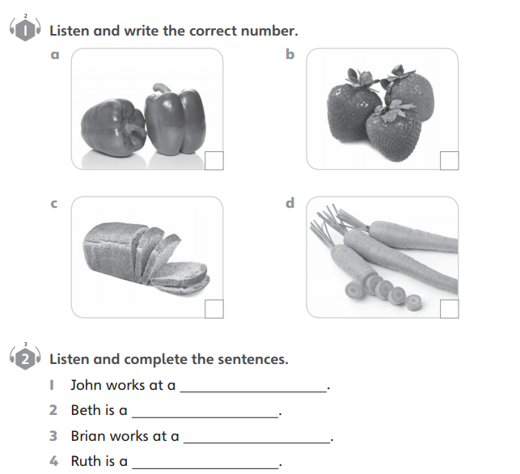
THURSDAY, SEPTEMBER 23RD,2021.
TOPIC: MY TEST GUIDE
4
2

3
1

RESTAURANT
VET
SUPERMARKET
POLICE OFFICER
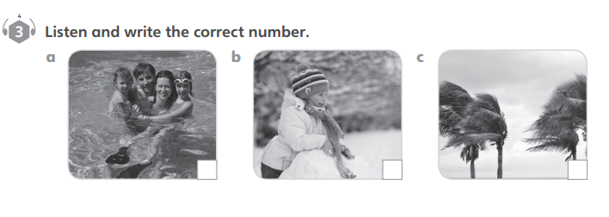

3
2
1
COLORING
DOING
EATING
LISTENING
PLAYING

