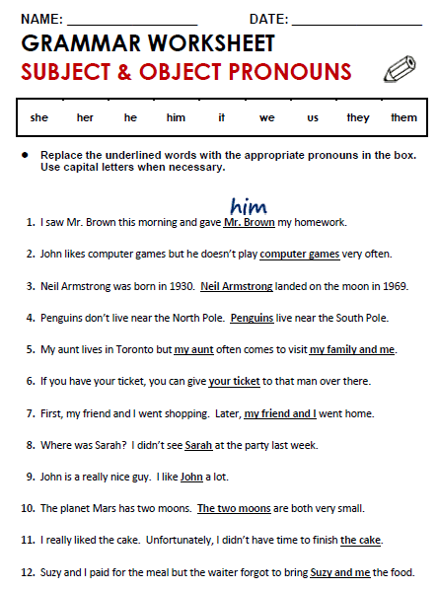

**THEM**

**HE**

**THEY**

**US**

**HE**

**IT**

**WE**

**HER**

**HIM**

**THEY**

**IT**

**US**

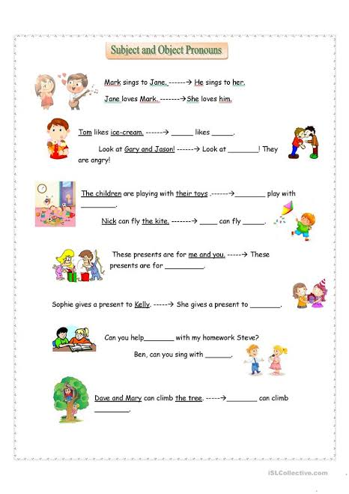

HE

IT

THEM

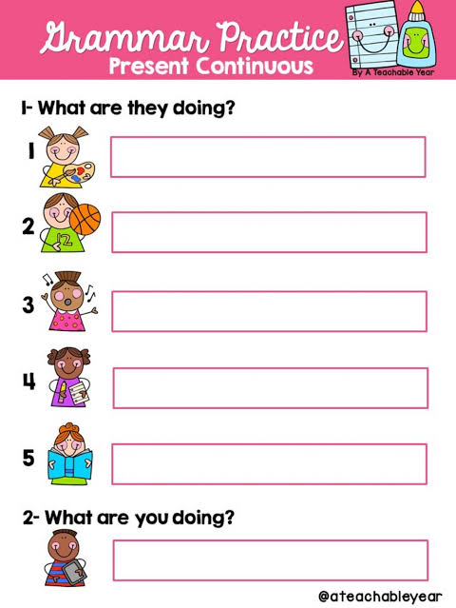

**I AM STUDYING ENGLISH**

**SHE IS READING**

**SHE IS WRITING**

**SHE IS SINGING**

**HE IS PLAYING BASKETBALL**

**SHE IS PAINTING**

