CONTENIDOS  TEMAS Y SUBTEMAS | SECUENCIA DIDACTICA  ACTIVIDADES |  |  | MATERIALES CURRICULARES DE APOYO Y RECURSOS DIDACTICOS
P-600  LUNES 22 NOV  THANKSGIVING ACTIVITIES  EXPLAIN THE HISTORY.  MARTES 23 NOV  PASTE FAJILLA  PASTE THE VOCABULARY  REPEAT THE VOCABULARY FROM 1-30.  MIERCOLES 24 NOV  TOPIC: PAST SIMPLE  WATCH A VIDEO  ANSWER WORKSHEETS.  JUEVES 25 NOV  TOPIC: WOULD  WATCH A VIDEO  ANSWER WORKSHEETS.  VIERNES 26 NOV  SB: PAGES 74-75.  WB: PAGES 62-63.  SUPERHEROES WORKSHEETS | INICIO | DESARROLLO | CIERRE | 1 hoja verde
 | ANSWER THE THANKSGIVING ACTIVITIES.  PASTE THE FAJILA  COPY THE TOPIC: PAST SIMPLE  COPY THE TOPIC: WOULD  ANSWER SB | MAKE A TURKEY  PASTE THE VOCABULARY  WATCH THE VIDEO  WATCH THE VIDEO  ANSWER WB | WATCH A VIDEO.  RREPEAT THE VOCABULARY  ANSWER THE WORKSHEETS  ANSWER THE WORKSHEETS  ANSWER THE WORSHEETS

THIRD PERIOD

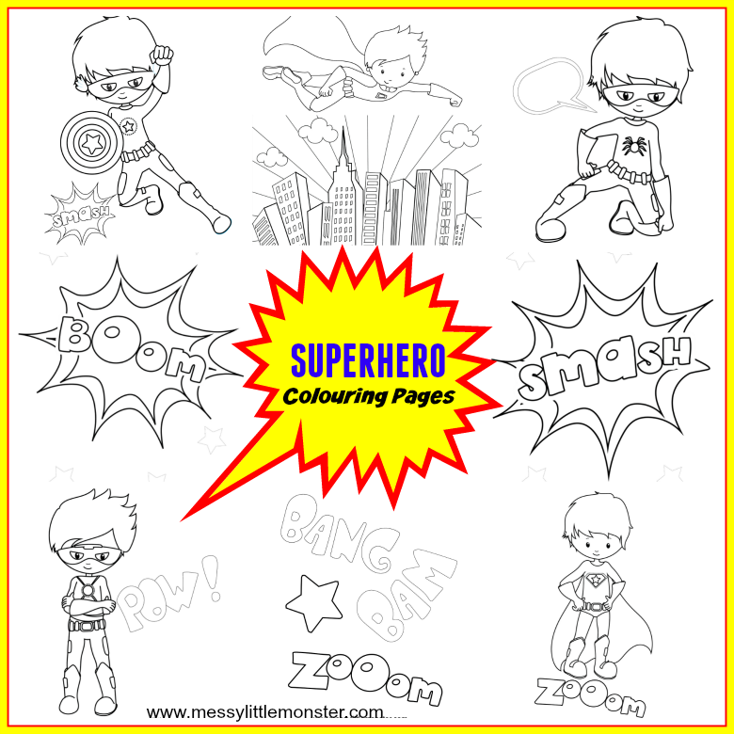

THIRD PERIOD

TOPICS FOR THIRD PERIOD
- PAST SIMPLE
- WOULD
- COULD
- SECOND CONDITIONAL
- SUPERPOWERS

VOCABULARY RELATED TO 3RD PERIOD

No. | Word | Meaning | Pronunciation
 | Able to disappear | Capaz de desaparecer | Eibol to diasapir
 | Fly | Volar | Flai
 | Have super strength | Tener super fuerza | Jav super istrengt
 | Read people’s mind | Leer las mentes | Rid pipols maind
 | Run at lighting speed | Correr a la velocidad de la luz | Ron at laitin espid
 | Travel through time | Viajar en el timpo | Travel dru taim
 | As it should be | Como debe ser | As it shuld bi
 | Go back in time | Regresar en el timpo | Go bak intaim
 | Let me think | Dejame pensar | Let mi tink
 | Not only that | No solo eso | Not onli dat
 | Quite a character | Personaje tranquilo | Cuait a character
 | That´s a hard one | Eso es dificil | Dats a jard wuan
 | What about you? | ¿ que hay de ti? | Wat abaut yu?
 | Adhesive | Pegamento | Adesib
 | Android | Androide | android
 | Armor | Armadura | Armor
 | Bolt of lighting | Relampagos | Bolt of laitin
 | Computer | Computadora | Compiuter
 | Designer | Diseñador | Disaigner
 | Digital | Digital | Digital
 | Electrodes | electrodos | Electrods
 | Gecko | Gecko | Gecko
 | Meteorite | Meteorito | Meteorit
 | Reflexes | Reflejos | Riflexex
 | Superhuman | Super humano | Superjiuman
 | Technology | Tecnologia | Tecnoloyi
 | Tweet | Tweet | Tuit
 | Wishes | Deseos | Wishes
 | Super powers | Super poderes | Super pawers
 | Barbecue | Asado | Barbekiu
 | Smoke | Humo | Ismok
 | Star | Estrella | Istar
 | Breathe | Respirar | Breith
 | Adhesive | Pegamento | Adhesib
 | Awareness | Conciencia | Aweniss
 | Ability | Habilidad | Ability
 | Birthday | Cumpleaños | Berdey
 | Cake | Pastel | keik
 | Calm
 | Dinosaur | Dinosaurio | Dainosaur
 | Clean up | Limpiar | Clinap
 | Have anything to eat | Tener de comer | Jav enithing to it
 | Have any job | Tener cualquier empleo | Jav eny yob
 | Talk to animals | Hablar con animales | Tok to animals
 | Stay | Estar | Istey
 | Beyond | Mas alla | Biyon
 | Sticky | pegajoso | Istiki
 | Slipping off | Resbalar | Isliping of
 | Monitor | Pantalla | Monitor
 | Keyboard | Teclado | Kibord
 | Speakers | Bocinas | Spekers
 | Recipe | Receta | Recipi
 | Odd jobs | Trabajos ocasionales | Odd yobs
 | Blowing air | Soplando aire | Blowing er
 | Tough | Duro | Taf
 | Thorn | espina | Torn
 | Swallowing | Tragar | Swalowing
 | Mission | Mision | Mishion
 | Hot air ballons | Globlos de aire caliente | Jot er baluns
 | Cure | cura | Kiur
 | Diseases | Enfermedades | Disis

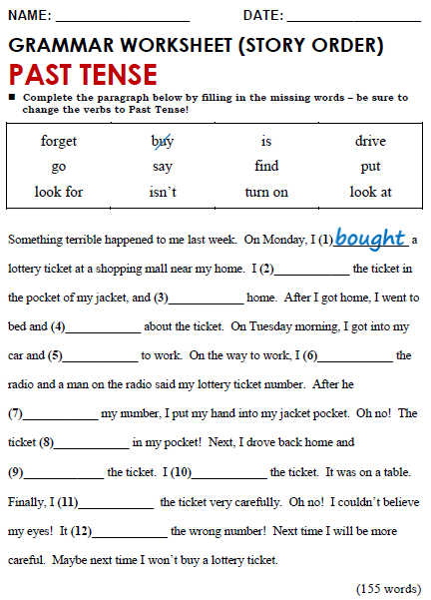

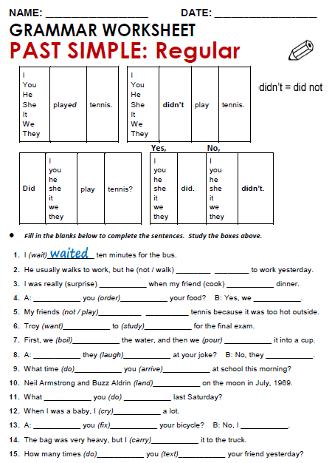

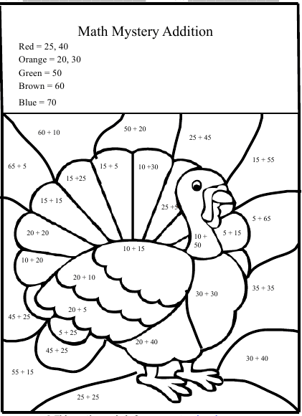

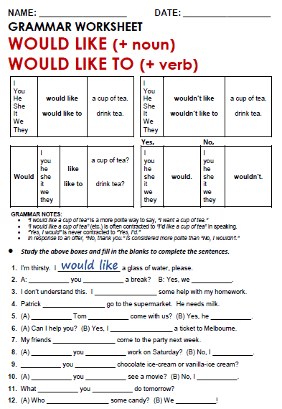

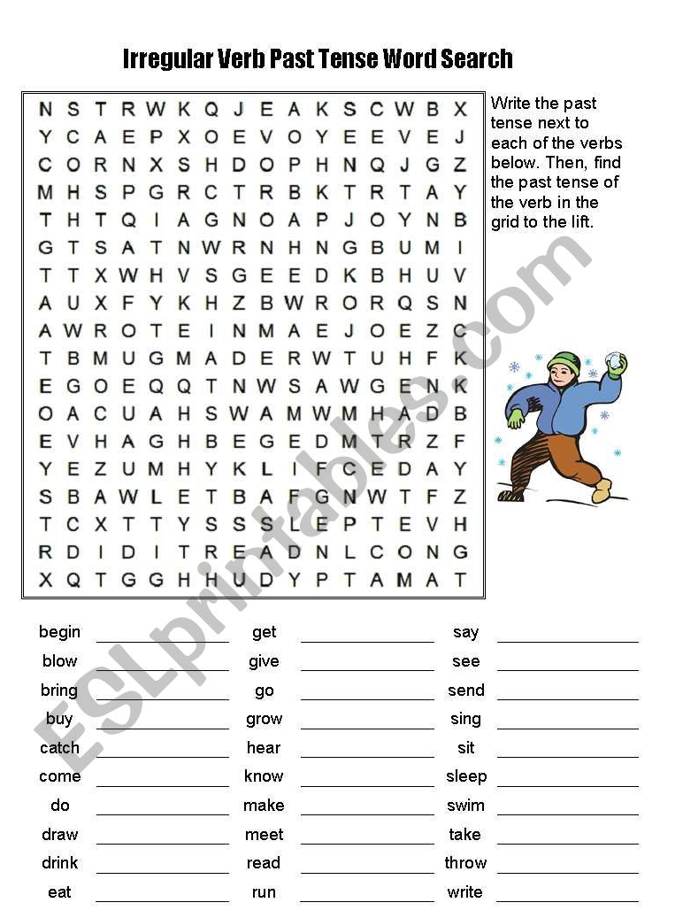

MONDAY, NOVEMBER 22TH, 2021.
TOPIC: PAST SIMPLE
EXPECTED LEARNING: KNOW WHEN TO USE THIS TENSE AND HOW.
PAST SIMPLE
We use the past tense to talk about:
- something that happened once in the past:
EXAMPLES:
I met my wife in 1983.
We went to Spain for our holidays.

- something that happened several times in the past:
- EXAMPLES:
When I was a boy, I walked a mile to school every day.
We swam a lot while we were on holiday.

something that was true for some time in the past:
EXAMPLES:
I lived abroad for ten years.
He enjoyed being a student.

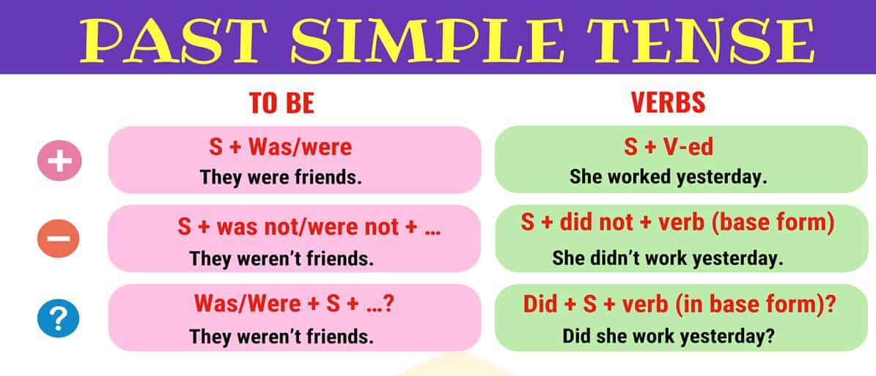

PAST SIMPLE WITH THE VERB TO BE

The affirmative form:
I, he, she, it | was.
you, we, they | were.

Examples:
- I was in London in 1999.
- Pam was in London in 1999, too.
- We were together.

The interrogative form:
Was | I, he, she, it?
Were | you, we, they?

Examples:
- Were you in London last year?
- Was Pam with you?
- Were you together?

The negative form:
I, he, she, it | was not.
 | wasn't.
You, we, they | were not.
 | weren't.

Examples:
- I wasn't in Paris in 1999.
- Pam wasn't in Paris in 1999.
- We weren't in Paris.

D.S:
VERB TO
- I WAS IN MEXICO
I WAS IN THE SCHOOL
2)WE WEREN’T IN ASIA
WE WEREN’T AT THE GYM YESTERDAY
3)WERE YOU IN SPAIN?
WERE YOU IN THE PARTY?

VERBS
- WORKED YESTERDAY
HE PLAYED WITH THE DOG
2)I DIDN’T WORK YESTERDAY.
HE DIDN’T PLAY WITH THE DOG
3)DID WORK YESTERDAY?
DID HE STUDY FOR THE TEST?

TOPIC: WOULD
EXPECTED LEARNING: KNOW HOW TO USE WOULD.
WOULD

Would is an auxiliary verb - a modal auxiliary verb. We use would mainly to:
- talk about the past
- talk about the future in the past
- express the conditional mood
We also use would for other functions, such as: expressing desire, polite requests and questions, opinion or hope, wish and regret.

Structure of would
The basic structure for would is:
subject | + | auxiliary verb  would | + | main verb

 | subject | auxiliary  would | not | main verb  base
+ | I | would |  | like | tea.
- | She | would | not | go.
? | Would | you |  | help?
Look at the basic structure again, with positive, negative and question sentences:
USES OF WOULD
- We often use would as a kind of past tense of will or going to:
EXAMPLE: I thought it would rain so I brought my umbrella.
- Using would as a kind of past tense of will or going to is common in reported speech:
EXAMPLE: She said that she would buy some eggs. ("I will buy some eggs.")
- We often use would not to talk about past refusals:
EXAMPLE: Yesterday morning, the car wouldn't start.

