CONTENIDOS  TEMAS Y SUBTEMAS | SECUENCIA DIDACTICA  ACTIVIDADES |  |  | MATERIALES CURRICULARES DE APOYO Y RECURSOS DIDACTICOS
BACHILLERATO 3  LUNES 30 AGOSTO  TOPIC: QUESTION WITH WHO AN WHAT  MARTES 31 AGO  MIERCOLES 01 SEP  WORKBOOK: PAGES  JUEVES 02 SEP  TOPIC: BE VS HAVE . DESCRIPTION | INICIO | DESARROLLO | CIERRE | NOTEBOOK, VIDEO  https://www.youtube.com/watch?v=ibmMybaXq4U  LIBRO, PLATAFORMA  LIBRO  LIBRETA VIDEO  https://www.youtube.com/watch?v=9h3EF9fSEMY
 | MAKE THE TOPIC  ANSWER STUDENT BOOK PAGE 18-19  UNIT 1: FINISH UNIT 1  MAKE THE TOPIC | EXPLAIN TO THEM  THEN ANSWER WORKBOOK PAGES  WORK ALONE TO UNDERTAND A THE UNIT 1  EXPLAIN TO THEM | ANSWERS THE DIDACTIC SEQUENCE  COMPARE ANSWERS  COMPARE ANSWERS  ANSWER THE ACTIVITY
AQUÍ DEBAJO COLOCAR LO QUE SE OCUPA IMPRIMIR
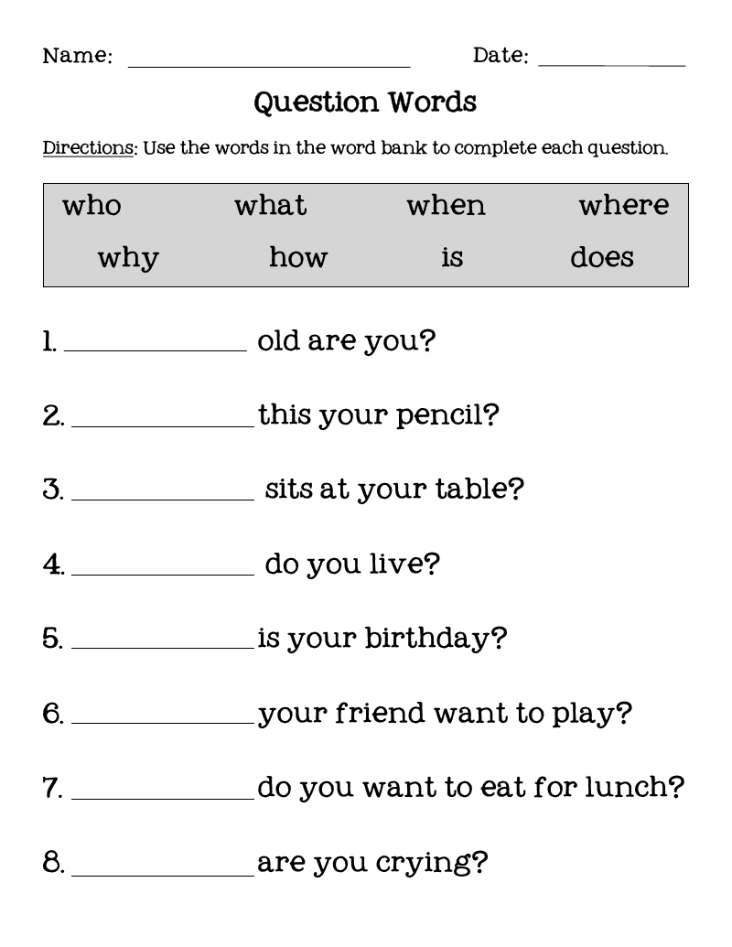

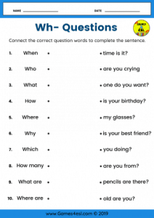

Thursday, September 2nd,2021.

WH- questions (Question Words)
There are two main types of questions: Yes/No questions and WH- question. WH-questions are questions starting with WH-words including: what, when, where, who, whom, which, whose, why and how.
Question words are used to ask about specific qualities, times, places, people and so on. Below is a list of question words and example sentences:

What | Used to ask about things | - What are you doing?  - What do you think about the movie?
When | Used to ask about time | - When will the meeting start?  - When are you leaving?
Where | Used to ask about places | - Where’s my bag?  - Where do you live?
Who | Used to ask about people | - Who do you love the most in your family?  - Who told you that story?
Whom | Used to ask about people (object of verb) | - Whom did you see in the morning? I saw Mr. Mark, my English teacher.  - Whom was Jim talking to? He was talking to Jack, his new roommate.
Which | Used to ask about choices | - Which one do you choose? The left or right?  - Of all the drinks in the menu, which one would you like?
Whose | Used to ask about possession | - Whose pencil is this? Is it yours?  - Whose books are these?
Why | Used to ask about reasons/ causes | - Why did it happen? I didn’t understand.  - Why is he crying?
How | Used to ask about manner/ process | - How can you explain this problem? Please tell us.  - How can you get here?

