CONTENIDOS  TEMAS Y SUBTEMAS | SECUENCIA DIDACTICA  ACTIVIDADES |  |  | MATERIALES CURRICULARES DE APOYO Y RECURSOS DIDACTICOS
P-600  LUNES 11 OCT  STUDENT BOOK: PAGES 36-39.  WORKBOOK: UNIT 3  KAHOOT  MARTES 12 OCT  Student BOOK: PAGES 40-41  WORKBOOK: UNIT 3 PAGES 33-35  MIERCOLES 13 OCT  EXAM  JUEVES 14 OCT  STUDENT BOOK: PAGES 42-45  WORKSHEETS  PLAY “MEMORAMA”  VIERNES 15 OCT  CONTENT CONNECTION :HISTORY | INICIO | DESARROLLO | CIERRE | KAHOOT DILEMMAS  https://kahoot.it/challenge/05205124?challenge-id=918d1a80-c6e7-4650-9829-077598c29c2b_1602185647874  PIN: 05205124  KAHOOT CONDITONALS  https://kahoot.it/challenge/09438511?challenge-id=918d1a80-c6e7-4650-9829-077598c29c2b_1602185926904  PIN: 09438511  MEMORAMA . BOOK  MAYANS VIDEO: https://www.youtube.com/watch?v=Q6eBJjdca14  KAHOOT MAYANS:  https://kahoot.it/challenge/06893072?challenge-id=918d1a80-c6e7-4650-9829-077598c29c2b_1602206527004  PIN: 06893072
 | STUDENT BOOK PAGES 36-39  ANSWER STUDENT BOOK  EXAM  ANSWER STUDENT BOOK  WATCH MAYANS VIDEO | START WITH WORKBOOK UNIT 3  USE PLATFORM  EXAM  ANSWER THE WORKSHEET  MAKE SOME MENTAL TOPIC IN THE NOTEBOK  ANSWER ACTIVITY | ANSWER THE PAGES ALONE AND COMPARE  ANSWER WORKBOOK ALONE  EXAM  PLAY MEMORAMA USING FIRST CONDITINAL  DICTATE SOME INFO.  DRAW THE MAIN ITEMS OF THE MAYANS  PLAY KAHOOT

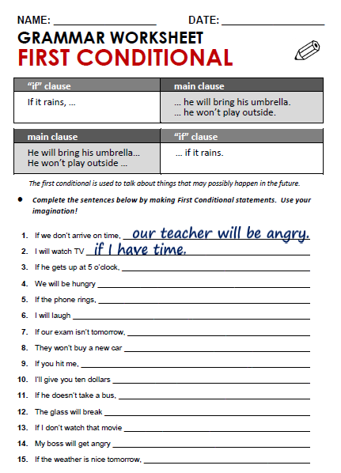

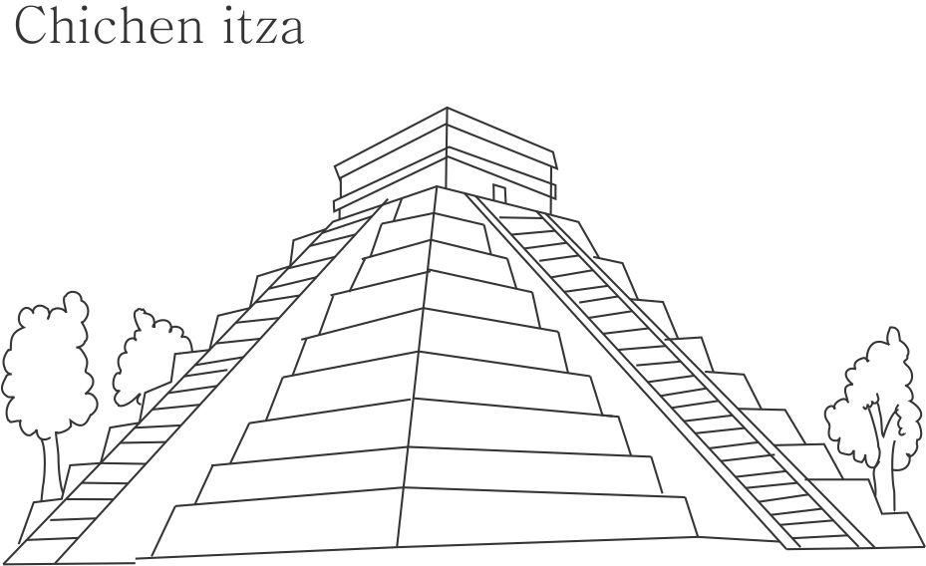

FRIDAY, OCTOBER 16TH,2020.
TOPIC: THE MAYANS CULTURE.
EXPECTED LEARNING: KNOW WHAT KIND OR INVENTIONS THE MAYANS DID.
THE MAYANS CULTURE.

FARMING

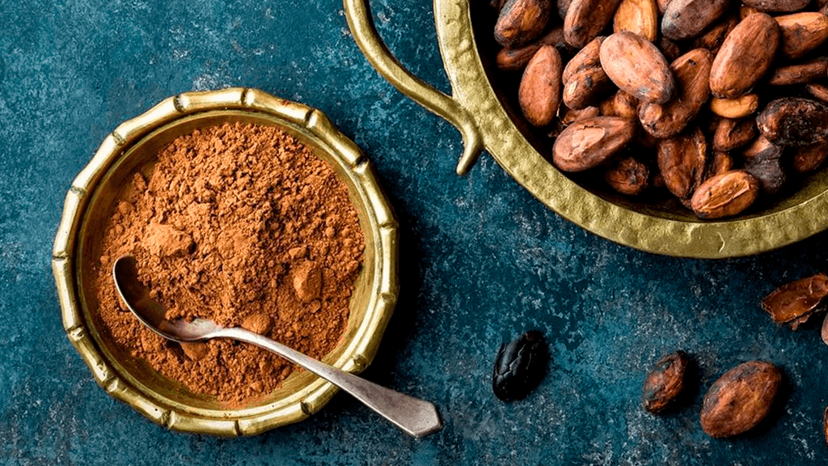
THE CALENDAR

