CONTENIDOS  TEMAS Y SUBTEMAS | SECUENCIA DIDACTICA  ACTIVIDADES |  |  | MATERIALES CURRICULARES DE APOYO Y RECURSOS DIDACTICOS
p-301  LUNES 9 NOV  SUSPENSION DE CLASES  MARTES 10 NOV  TOPIC:REPORTED SPEECH  MIERCOLES 11 NOV  TOPIC:USED TO AND WOULD  JUEVES 12 NOV  TOPIC: SO, EITHER, TOO AND EITHER WITH SIMPLE PRESENT  VIERNES 13 NOV  TOPIC:PASSIVE VOICE | INICIO | DESARROLLO | CIERRE
 | COPY THE TOPIC  COPY THE TOPIC  COPY THE TOPIC  COPY THE TOPIC | EXPLAIN IT  EXPLAIN IT  EXPLAIN IT  EXPLAIN IT | ANSWERS WORKSHEETS  ANSWERS WORKSHEETS  ANSWERS WORKSHEETS  ANSWERS WORKSHEETS

TERM
- REPORTED SPEECH
- USED TO AND WOULD
- SO, EITHER, TOO AND EITHER WITH SIMPLE PRESENT
- SIMPLE PRESENT AND PAST PASSIVE
ENGLISH WORD | MEANING
EMBARRASED | APENADO
FRUSTATED | FRUSTRADA
MAD | ENOJADA
TENSE | TENSO
COMMUNICATE CLEARLY | COMUNICAR CLARO
HAVE EXPERIENCE | TENER EXPERIENCIA
BRAINSTORM IDEAS | LLUVIA DE IDEAS
OFFER SUGESTIONS | OFRECER SUGERENCIAS
SET UP CLEAR GOALS | ESTABLECER METAS CLARAS
STAY ON SCHEDULE | ESTAR EN TIEMPO
GIVE FEEDBACK | DAR RETROALIMENTACION
CREATE AN AGENDA | CREAR UNA AGENDA
BE CONFUSED | ESTAR CONFUNDIDO
CLARIFY | ACLARAR
FIGURE OUT | DESCIFRAR
MISUNDERSTAND | MAL ENTENDIDO
ASSUME | ASUMIR
FLEXIBLE | FLEXIBLE
AN ASSUMPTION | UNA SUPOSICION
RELEVANT | RELEVANTE
A CRIMINAL | UN CRIMINAL
STAY IN TOUCH | MANTENERSE EN CONTACTO
MEET IN PERSON | CONCER EN PERSONA
CONNECT ONLINE | CONECTARSE EN LINEA
SHOP ONLINE | COMPRAR EN LINEA
POST ON SOCIAL MEDIA | PUBLICAR EN REDES SOCIALES
WRITE A BLOG | ESCRIBE UN BLOG
VIDEO CHAT | VIDEO CHAT
CATCH UP | ALCANZAR
SCIENCE FICTION | CIENCIA FICCION
COMEDY | COMEDIA
SUSPENSE | SUSPENSO
SCULPTURE | ESCULTURA
ADAPT | ADAPTARSE

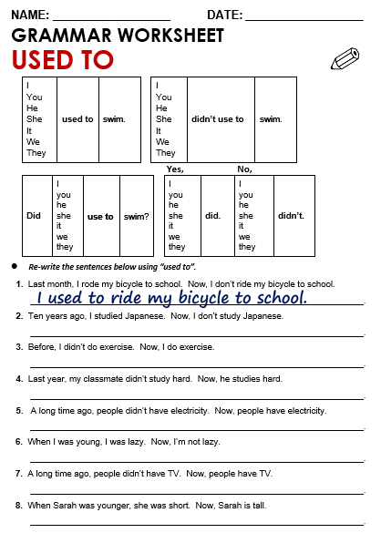
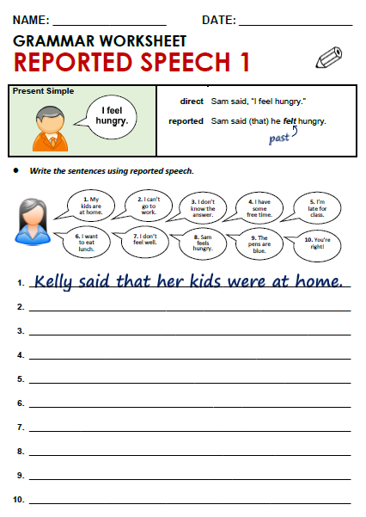

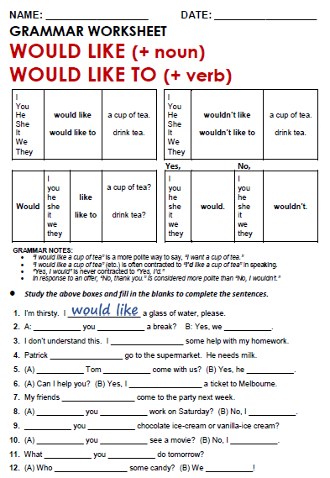

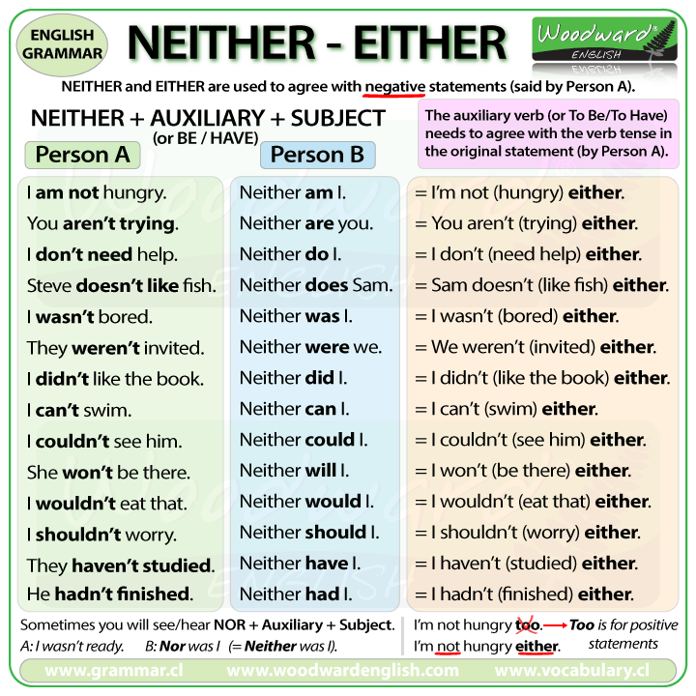

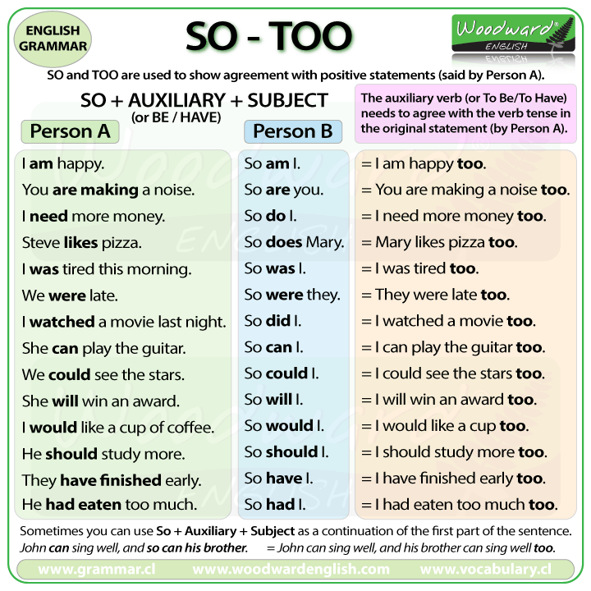
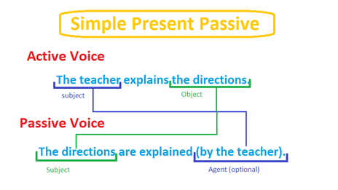

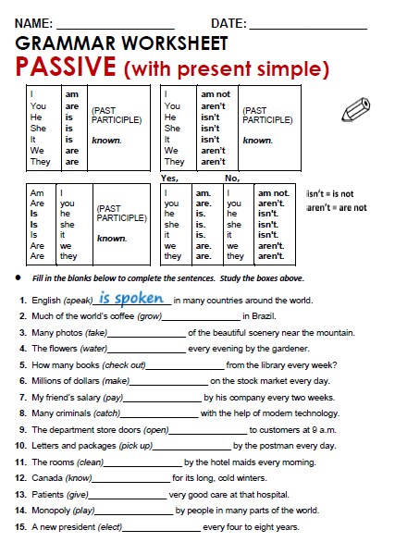

TUESDAY, NOVEMBER 17TH, 2020.
TOPIC: REPORTED SPEECH.

Kelly said that she couldn’t go to work
Kelly said that she didn’t know the answer
Kelly said that she was late for class.
Kelly said that she wanted to eat lunch.
Kelly said that you were right.
Kelly said that the pens were blue.
Kelly said that he felt hungry.
Kelly said that she didn’t feel well.
Kelly said that she had some free time.

USED TO
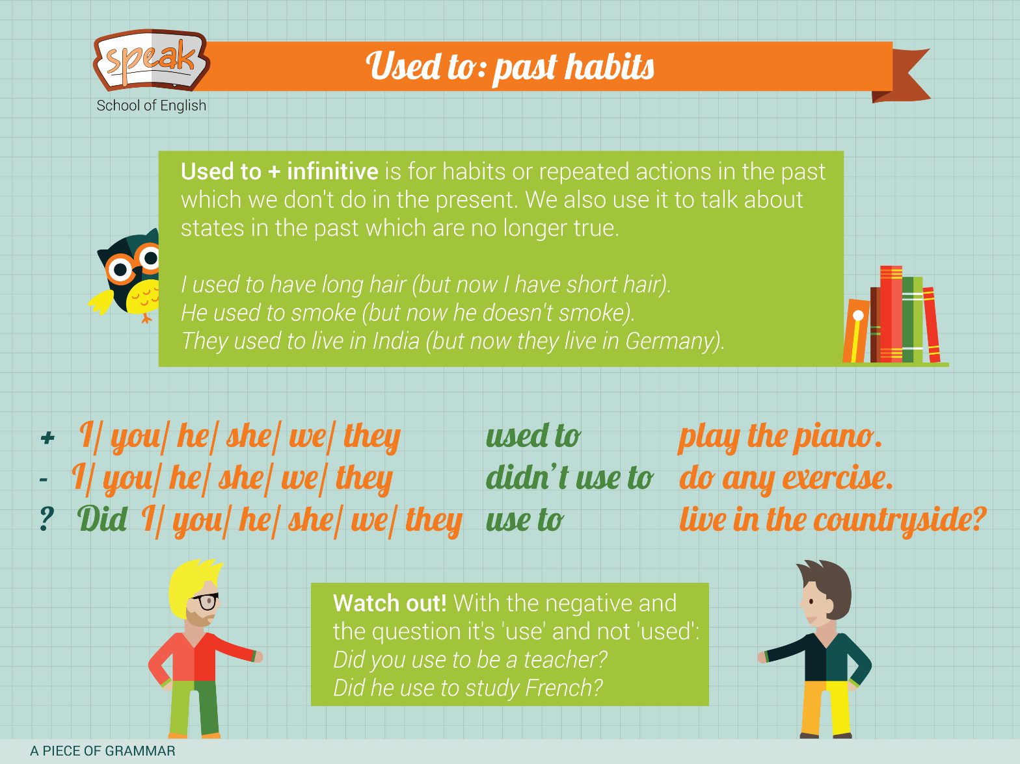

WOULD WOULD VS USED TO

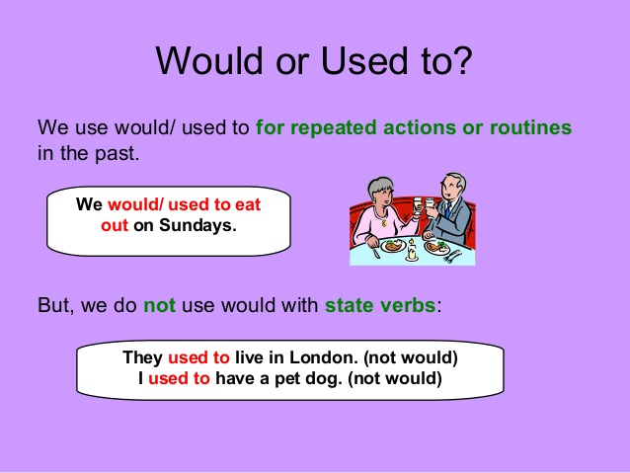

THURSDAY, NOVEMBER 19TH, 2020.
TOPIC: SO, EITHER, TOO AND NEITHER WITH SIMPLE PRESENT

DIDACTIC SEQUENCE:

SO/TOO
I HAVE A LOT OF FRAGANCES.
(DO/DOES)
SO DOES VALERIA.
VALERIA DOES TOO

PAOLA CAN SWIM
SO CAN CHRISTOPHER.
CHRISTOPHER CAN TOO.

3-JASON IS VERY POLITE
SO IS PAOLA.
PAOLA IS TOO.
4-PAOLA HAS A BIG PROBLEM
SO HAS FERNANDA
FERNANDA HAS TOO.
5-VALE CAN GO TO THE PARTY
SO CAN CRISTOBAL
CRISTOBAL CAN TOO

NEITHER/EITHER
- PAOLA WON’T GO TO HOME
NEITHER WOULD QUET.
QUET WONT EITHER.

- I DON’T HAVE MONEY
NEITHER DO VALERIA
VALERIA DON’T EITHER

- I WON’T KISS MY BOYFRIEND.
NEITHER WOULD LUPITA
LUPITA WONT EITHER

- PAOLA IS NOT A DOCTOR
NEITHER IS YADHIRA
YADHIRA IS NOT EITHER

