CONTENIDOS  TEMAS Y SUBTEMAS | SECUENCIA DIDACTICA  ACTIVIDADES |  |  | MATERIALES CURRICULARES DE APOYO Y RECURSOS DIDACTICOS
P-301  13 SEP  STUDENT BOOK: PAGES 21-23  14 SEP  WORKBOOK: PAGES 20--22  WORKSHEETS  15 SEP  ACTIVITIES OF PRESENT SIMPLE AND DAILY ACTIVITIES  16 SEP  SUSPENSION DE LABORES  17 SEP  STUDENT BOOK: 24-27  ACTIVITIES: PRESENT SIMPLE. | INICIO | DESARROLLO | CIERRE | STUDENT BOOK, PLATFORM.  HOJAS IMPRESAS, LIBRO.  HOJAS IMPRESAS  HOJAS IMPRESAS AND BOOK
 | ANSWER STUDENT BOOK.  ANSWERS THOSE PAGES .  ANSWER A LITTLE GUIDE.  ANSWER THE BOOK | COMPLETE THOSE PAGES USING THE PLATFORM.  EACH STUDENT HAS TO ANSWER THE EXCERCISES ALONE.  ANSWER ALONE AND COMPLETE EACH EXCERCISE.  ANSWER THE ACTIVITIES | COMPARE ANSWERS AND COMPLETE IT.  COMPARE ANSWERS.  ANSWERS WORKSHEETS.  MAKE A REVEW  CHECK IT ALL
AQUÍ DEBAJO COLOCAR LO QUE SE OCUPA IMPRIMI
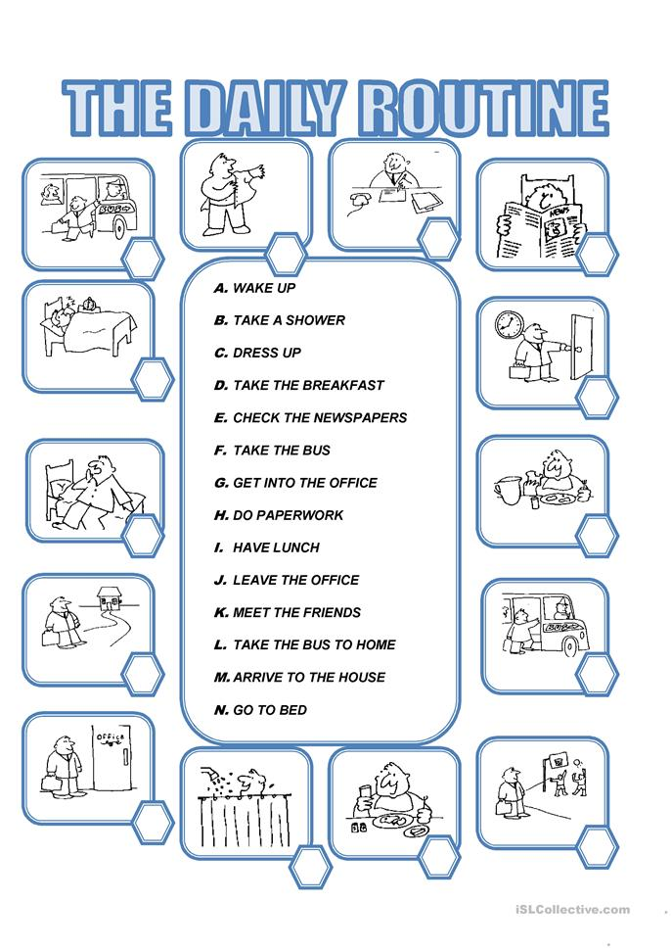
TUESDAY, SEPTEMBER 14TH, 2021.
TOPIC: DAILY ROUTINES

L
H
E
C

J
N

D
A

M
F

G
K
I
B

UNDERLINE THE SUBJECT IN BLUE AND THE VERB IN RED

1.- PARENTS GIVE GOOD ADVICE.
2.- SOAP KILLS BACTERIA.
3.- I SHOWER EVERY DAY.
4.- TOOTHPASTE CLEANS YOUR TEETH.
5.- YOU HAVE NICE TEETH.

COMPLETE THE SENTENCES USE DO DOES
1.- WHAT DOES A BARBER DO?
2.- WHERE DO WAITERS WORK?
3.- WHERE DOES A STORMCHASER WORK?
4.- WHAT DO YOU DO?
5.- WHERE DOES SHE WORK?
6.- WHAT DOES YOUR DAD DO?
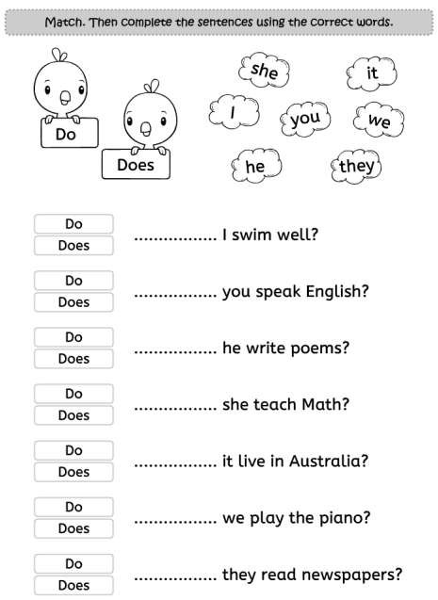

DO

DO

DOES

DOES

DOES
DO
DO
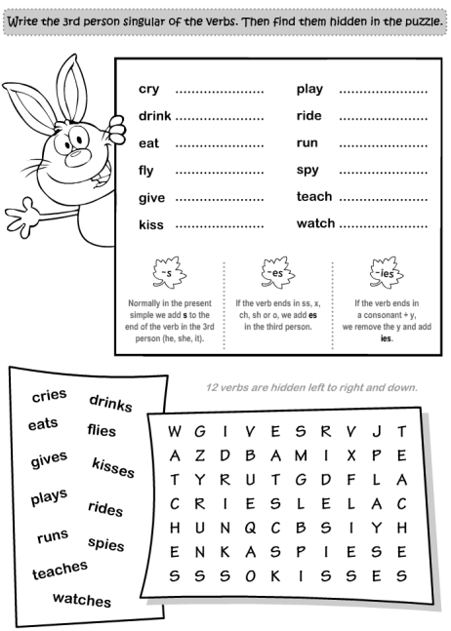
1-CRIES 7-PLAYS
2-DRINKS 8-RIDES
3-EATS 9-RUNS
4-FLIES 10-SPIES
5-GIVES 11-TEACHES
6-KISSES 12-WATCHES

