CONTENIDOS  TEMAS Y SUBTEMAS | SECUENCIA DIDACTICA  ACTIVIDADES |  |  | MATERIALES CURRICULARES DE APOYO Y RECURSOS DIDACTICOS
NIVEL 3 FORMATIVE  LUNES 30 AGOSTO:  WORKBOOK: PAGES  MARTES 31 SEP:  TOPIC: PRESENT CONTINUOUS  MIERCOLES 01 SEP :  STUDENT BOOK PAGES  JUEVES 02 SEP :  STUDENT BOOK: PAGES  VIERNES 03 SEP :  REVIEW OF TOPICS:  ANSWER WORKSHEET | INICIO | DESARROLLO | CIERRE | PLATFORM AND BOOK  NOTEBOOK, VIDEO AND WORKSHEET  ANSWER STUDENT BOOK  PLATFORM AND BOOK  NOTEBOOK
 | START WITH THE BOOK  TOPIC: INTRODUCE THE TOPIC  CONTINUE WITH THE BOOK AND PARTICIPATE  FINSH UNIT 1  ANSWER WORKSHEETS | SHARE TO THEM THE PLATFORM  PRESENT A VIDEO  UNIT 1 : EXPLAIN WITH PLATFORM  USE THE TENSES PRESENT SIMPLE AND CONTINUOUS  MAKE SOME ACTIVITES | ANSWER N GROUPS  ANSWER ACTVITY  MAKE THEM TO PARTICIPATE  USE PLATFORM  COMPARE ANSWERS
AQUÍ DEBAJO COLOCAR LO QUE SE OCUPA IMPRIMIR

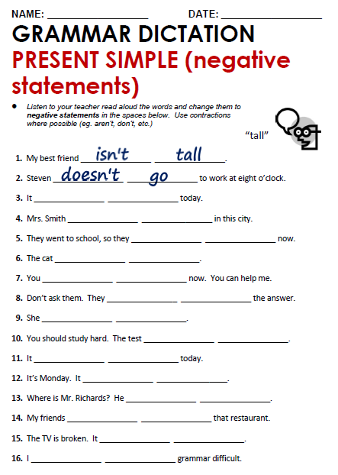

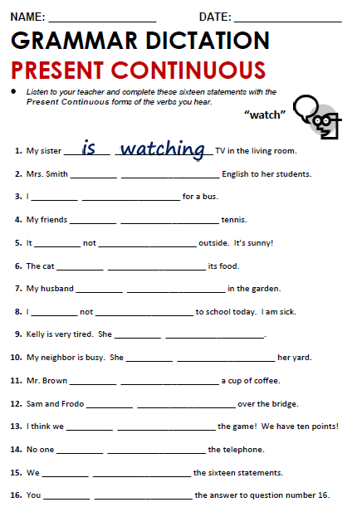

TUESDAY, AUGUST 31ST, 2021.
TOPIC: PRESENT CONTINUOUS
EL: KNOW THIS TENSE AND HOW TO USE IT

The present continuous is made from the present tense of the verb be and the –ing form of a verb
We use the present continuous to talk about:
- activities at the moment of speaking:
I'm just leaving work. I'll be home in an hour.
Please be quiet. The children are sleeping.

- future plans or arrangements:
Mary is going to a new school next term.
What are you doing next week?

Present continuous questions
We make questions by putting am, is or are in front of the subject:
Are you listening?
Are they coming to your party
We make negatives by putting not (or n't) after am, is or are:
I'm not doing that.
You aren't listening. (or You're not listeninG

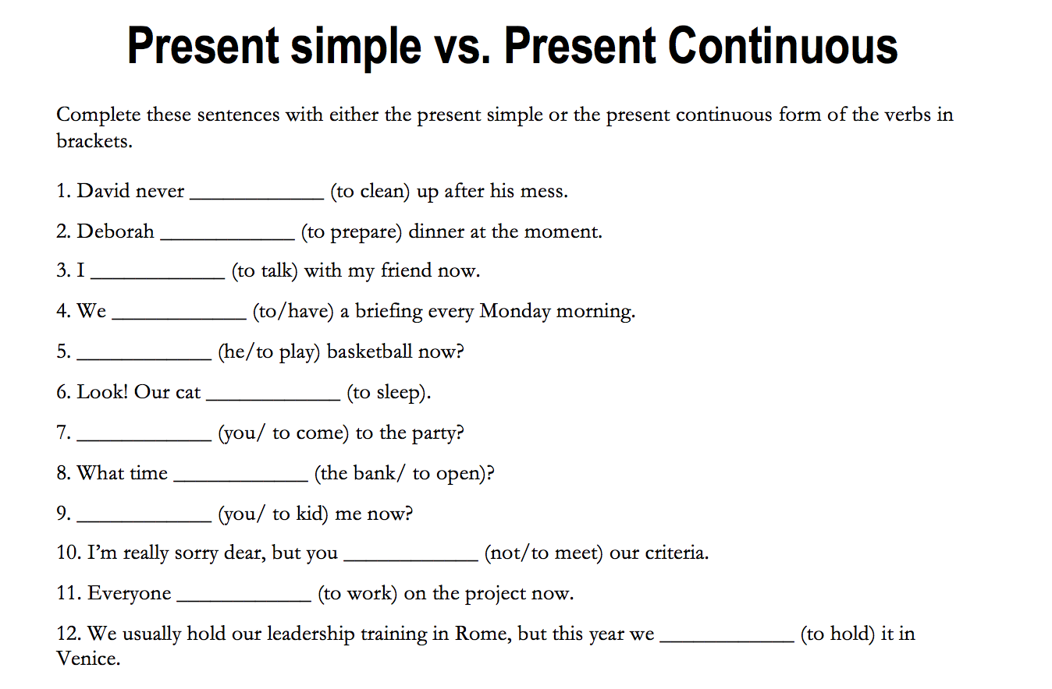
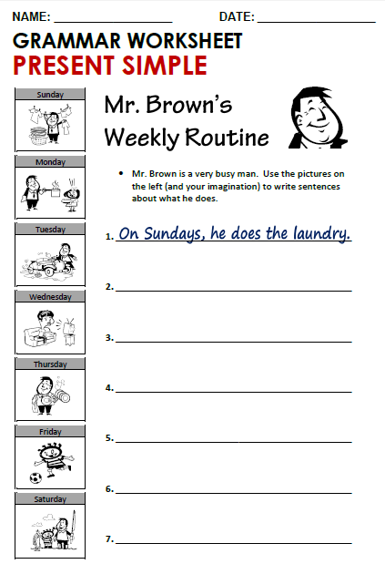

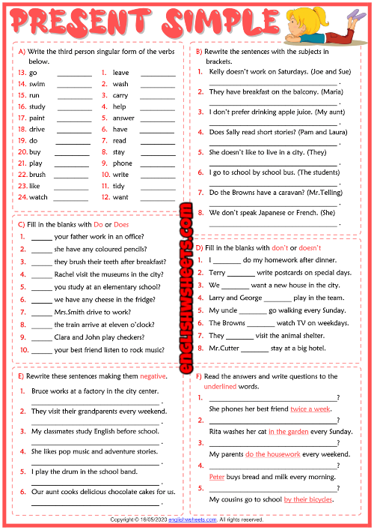

13-GOES 1-LEAVES
14-SWIMS 2-WASHES
15-RUNS 3-CARRIES
16-STUDIES 4-HELPS
17-PAINTS 5-ANSWERS
18-DRIVES 6-HAS
19-DOES 7-READS
20-BUYS 8-STAYS
21-PLAYS 9-PHONES
22-BRUSHES 10-WRITES
23-LIKES 11-TIDIES
24-WATCHES 12-WANTS

1-JOE AND SUE DON’T WORK ON SATURDAYS
2-MARIA HAS BREAKFAST……..
3-MY AUNT DOESN’T PREFER……..
4-DO PAM AND LAURA READ..?
5-THEY DON’T LIKE….
6-THE STUDENTS GO TO SCHOOL….
7-DOES MR. TELLING HAVE …?
8-SHE DOESN’T SPEAK ……

1-DOES
2-DOES
3-DO
4-DOES
5-DO
6-DO
7-DOES
8-DOES
9-DO
10-DOES

1-DON’T
2-DOESN’T
3-DON’T
4-DON’T
5-DOESN’T
6-DON’T
7-DON’T
8-DOESN’T

1-BRUCE DOESN’T WORK……..
2-THEY DON’T VISIT……..
3-MY CLASSMATES DON’T STUDY…..
4-SHE DOESN’T LIKE……..
5-I DON’T PLAY…….
6-OUR AUNT DOESN’T COOK…
1-HOW MANY TIMES DOES SHE PHONE HER BF?
2-WHERE DOES RITA WASH HER CAT?
3-WHAT DO YOUR PARENTS DO EVERY WEEKEND?
4-WHO BUY BREAD AND MILK EVERY MORNING?
5-HOW DO YOUR COUSINS GO TO SCHOOL?

