CONTENIDOS  TEMAS Y SUBTEMAS | SECUENCIA DIDACTICA  ACTIVIDADES |  |  | MATERIALES CURRICULARES DE APOYO Y RECURSOS DIDACTICOS
P-600  LUNES 4 OCT  ANSWER THE ACTIVITIES OF FRIDAY  WATCH A SONG VIDEO USING THE CONDITIONALS  TOPIC: WILL  MARTES 5 OCT  ANSWER ACTIVITIES OF WILL  UTILIZAR PLATAFORMA KAHOOT  TOPIC: SHOULD/SHOULDN`T  MIERCOLES 6 OCT  WATCH A VIDEO  ANSWER ACTIViTIES OF SHOULD.  WATCH A DOCUMENTARY AND WRITE ADVICES.  Use KAHOOT  JUEVES 7 OCT  PLAY BINGO WITH CONDITIONALS.  WATCH SOME SKETCHES MOVIES AND LISTEN PHRASES OF CONDITIONAL.  STUDENT BOOK: PAGES 36-37  VIERNES 8 OCT  VOCABULARY  WORKBOOK: UNIT 3 | INICIO | DESARROLLO | CIERRE | https://www.youtube.com/watch?v=vjoZvhzWfxI  https://www.youtube.com/watch?v=2oumWdjA9hM&t=59s  https://www.youtube.com/watch?v=hKFV9IquMXA  https://www.youtube.com/watch?v=oNfWRltjDEk  https://www.youtube.com/watch?v=ZluE8MUNe0Y  https://www.youtube.com/watch?v=HvX4BF9s6_w
 | Answer worksheets  Answer worksheets  Worsheets  Kahoot  USE KAHOOT, READING COMPREHENSION.  CONTINUE WITH VOCABULARY | Iisten to a song that has 1st conditionals AND WRITE THE PHRASES EN THE NOTEBOOK  Activity in kahoot  Watch a documentary and give advices and write in the notebook a short essay.  Play BINGO  START WITH WORKBOOK | Copy the topic will and explain it.  Copy the topic  Use the topic should to give advices .  WATCH SKETCHES OF MOVIES THAT HAVE CONDITIONALS AND WRITE THEM.  COMPARE ANSWERS

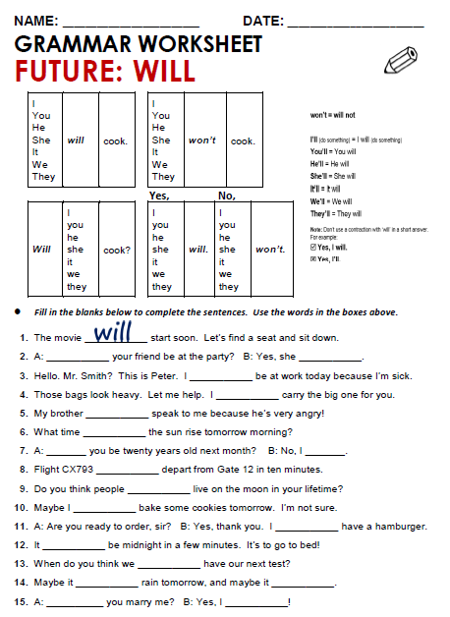
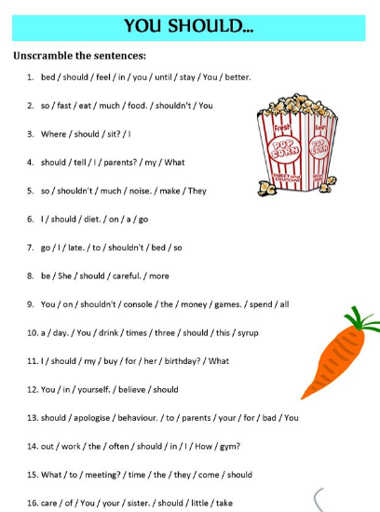

TUESDAY, OCTOBER 5TH, 2021.
TOPIC: WILL
EXPECTED LEARNING: HOW TO EXPRESS IDEAS IN THE FUTURE

Used to talk about what is going to happen in the future, especially things that you are certain about or things that are planned.
EXAMPLE: Clare will be five years old next month.

Used to talk about what someone or something is able or willing to do:
EXAMPLE: I'll give you a ride.
Used as a polite way of inviting someone to do something, or of offering someone something:
EXAMPLE: Will you join us for a cup of coffee, Evie?
WILL

Used in conditional sentences with 'if':
EXAMPLE: If he's late again, I'll be very angry.
Used when referring to something that always or usually happens:
EXAMPLE: Accidents will happen.

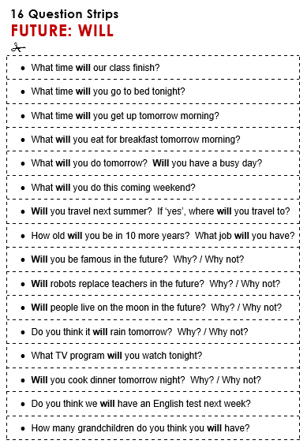

TUESDAY, OCTOBER 12ND, 2021.
TOPIC: SHOULD/ SHOULDN’T
EXCPECTED LEARNING: KNOW HOW AND WHEN WE CAN USE IT.
SHOULD/ SHOULDN’T

Should is an auxiliary verb - a modal auxiliary verb. We use should mainly to:
- give advice or make recommendations
- talk about obligation
- talk about probability and expectation
- express the conditional mood
- replace a subjunctive structure

